Unit 4.1 Assignment: Visual Design Challenge

Zachary Howell
School of Arts and Sciences, Post University
CIS 311: Technical Writing in CIS
Professor Vincent Tran
May 31, 2026

Unit 4.1 Assignment: Visual Design Challenge
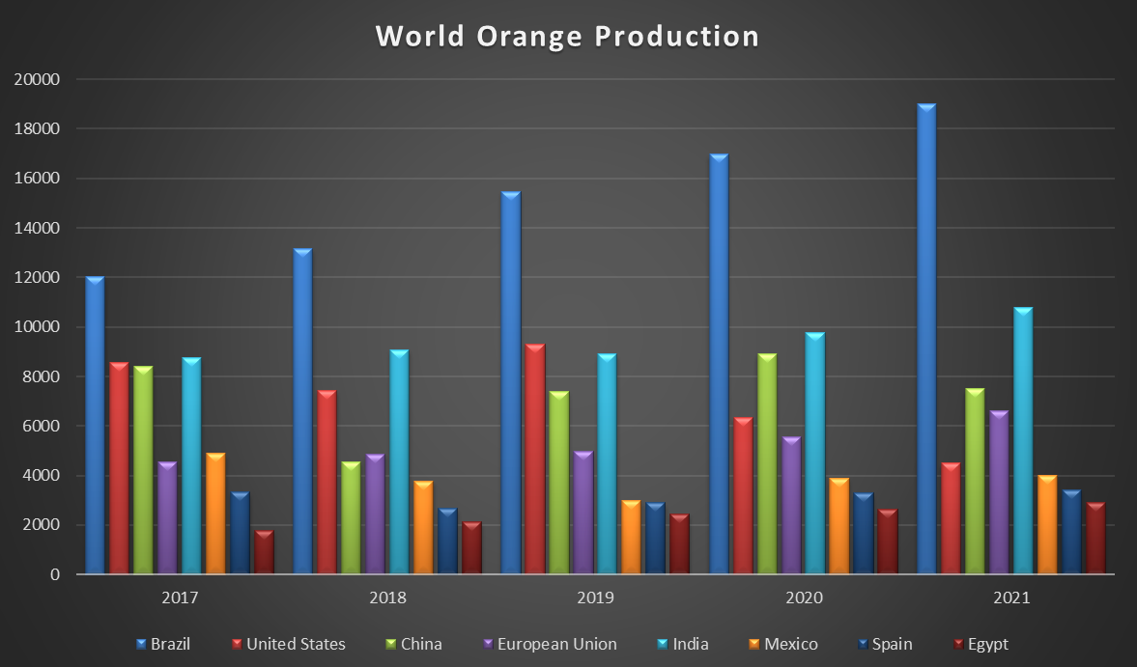
The table and the accompanying chart summarize world orange production (including tangerines) for eight major producing regions from 2017 through 2021. The visual presentation makes it easy to compare production levels and identify trends over time. As shown in the table and chart, Brazil was consistently the largest producer and experienced substantial growth, increasing from 12,053 thousand metric tons in 2017 to 18,998 thousand metric tons in 2021. India also demonstrated steady growth throughout the period, reaching 10,806 thousand metric tons by 2021. In contrast, the United States showed a significant decline in production, falling from 8,562 thousand metric tons in 2017 to 4,500 thousand metric tons in 2021. The European Union and Egypt exhibited consistent increases, while China and Mexico experienced fluctuations from year to year. Overall, the data indicate that global orange production trends varied considerably among regions, with some countries expanding production capacity while others faced declining output. The chart effectively highlights these differences and provides a clear visual comparison of production patterns over the five-year period.

